Answer the following questions completely.

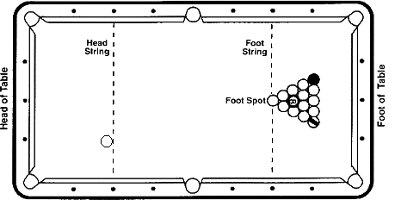
- Which ball will break out of the rack with the greatest velocity?

- Draw the path that ball is likely to follow?

- Explain why the ball will follow the path you have drawn.

Corrections to your original thoughts:

- Which ball will break out of the rack with the greatest velocity?

- Draw the path that ball is likely to follow?

- Explain why the ball will follow the path you have drawn.

Corrections to your original thoughts:

- Which ball will break out of the rack with the greatest velocity?

- Draw the path that ball is likely follow?

- Will that ball move faster or slower than in the previous example?

- Explain why the ball will follow the path you have drawn.

Corrections to your original thoughts:

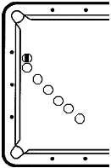
- Which ball will move with the greatest velocity after contact?

- Draw the path that both balls are likely to follow?

- Will the object ball move faster or slower than the cue ball?

- Why?
The white balls represent one moving ball.
- Explain why the ball will follow the path you have drawn.

Corrections to your original thoughts:

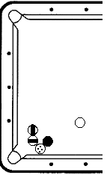
- Which ball will move with the greatest velocity after contact?

- Can the horizontally striped ball be made legally?

- Draw the path that the other 4 balls are likely to follow?

- Why?

- Explain why the ball will follow the path you have drawn.

Corrections to your original thoughts:

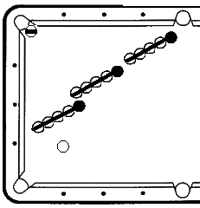

- Can the horizontally striped ball be pocketed legally?
(Scooping – hitting the bottom of the cue ball is NOT legal!)

- Draw the path that the balls are likely to follow?

- Explain why the ball will follow the path you have drawn.

Corrections to your original thoughts:

