 BioDome Resources 2004

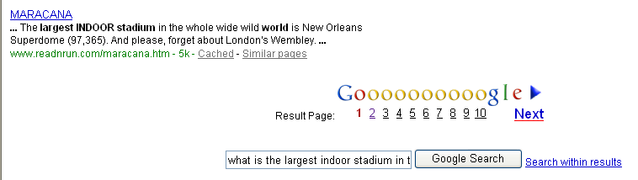



Superdome Statistics
Total Land Area: (building, garages, and grounds) | 52 acres
Height: | 273 feet (82.3 meters)
Diameter of Dome: | 680 feet (210 meters)
Area of Roof: | 9.7 acres
Interior Space: | 125,000,000 cubic feet
Total square footage: | 269,000 sq. ft. (82,342 sq. meters)
Main Arena: | 166,180 sq. ft. (50,685 sq. meters)
Convention Concourse: | 76,711 sq. ft. (8,261 sq. meters)
Concrete: | 169,000 cubic yards (131,820 cubic meters)
Structural Steel: | 20,000 tons (18,200 metric tons)
Air Conditioning: | 9,000 tons (8,190 metric tons)
Meeting Rooms (200 Loge Level): | Four 19,000 square foot quadrant rooms (each divisible into 6 individual rooms, 28 smaller reception rooms)
Rest rooms: | 102 (51 women's & 51 men's)
Private Box Suites: | 137
Parking Capacity: | 5,000 cars & 250 buses
Air Conditioning: | 9,000 tons
Lighting: | 19,507 fixtures utilizing 27,869 lamps
Video System: | 2 DiamondVision panels, each 28'7"x 36'3"
Scoreboards: | 4 message/scoreboards, each 8'x 88' 2 out-of-town scoreboards, each 4.5'x 46'
Electrical Wiring: | 400 miles (640 kilometers), including fiber optic lines
Anodized Aluminum Siding: | more than 550,000 sq. ft.
Escalators: | 42
Elevators: | 14 (9 passenger & 5 freight )
Maximum Seating Capacity: | football 69,703, expanded football 72,003, arena concerts 20,000, basketball 55,675, baseball 63,525
Press Seating: | 334 (football & baseball press boxes, and 11 broadcast/spotting booths).
Artificial Turf: | AstroPlay - 208 feet by 408 feet, (84,864 square feet

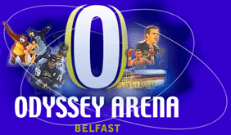
Technical Information
To contact a member of our team please call us on 028 9076 6000.
Technical Specifications
Exhibition/Conference area
Up to 3,658 sq m main area, (length 79m x 46m width) plus concourse.
Ceiling Height
Maximum 22m clearance from floor to underside to roof beams.
Truck Entrance
3 entrance doors: - 2 @ 3.5m x 4m, 1 @ 7m x 4m.
Floor Loadings
From 2000kg per sq m to 5000kg per sq m of Uniformly Distributed Load. Specific point loading of 1000kg per sq m.
Layout Capacity (Maximum)
End stage seated: | 8,700
Centre stage seated: | 10,000
Half house seated: | 4,700
All standing: | 10,000
End stage standing: | 10,000
Centre stage standing: | 10,000
Half house standing: | 5,500
Suites/VIP's | 388
Various configurations possible including centre stage & other seated layouts, up to approximately 10,000.
Equipment
Permanent ice floor & ice hockey facilities.
200m running track, and 60m sprint track with run-off.
Long jump/triple jump, high jump & pole vault facilities available, plus full warm up areas. Dividable motorised curtain to subdivide arena if required.
Clearcom intercom system.
4 x Xenon Supertrooper 2 x followspots.
2 x forklifts.
Back to top
Corporate Hospitality
24 x luxury suites accommodating up to 28 people (20 @ 4m x 6m, and 4 @ 6m x 6m).
VIP lifts available at dedicated entrances.
Refreshment serving area including refrigeration. Choice of catering.
Remote control colour TV's.
Media Facilities
2 media galleries (6m x 6m) with 32 seats in each.
Telecommunications equipment available.
Power points in each gallery. Interview facilities if required.
Back to top
Stage Construction
Stage Right ME3750 rolling stage, maximum size is 60ft x 44ft, at 6ft high. PA wings of up to 12ft x 24ft. Mixer platform available up to 24ft x 16ft.
Electrical Power
Stage Right | 400amp TPN
Stage Left | 400amp TPN
Centre | 400amp TPN
Outside Broadcast | 400amp TPN
Rigging | 100amp TPN
Camera/Follow spot | 100 amp TPN & 63 amp TPN
Light
House capable of 1400 Lux.
60 x Tungsten halogens of 200W/500W.
Combination of 5 levels of sports lights.
Dimmable house lights.
Back to top
Dressing Rooms/Production Offices
4 large team dressing/locker rooms for 22 persons, sub dividable with changing areas, all with toilet & shower facilities.
Coach, trainer & drugs test room available.
8 x multiple use rooms of various sizes.
Telephone & data points available in each area.
Hospitality
Meeting room & lounge available on dressing room.
Corridor (45sq m in size). Harbour room (35sq m). Millennium room (75sq m). Press Lounge (42sq m). Various other suites available.
Sound
Full pa system available.
Scoreboard
Four sided 5m x 2.2m matrix display ice hockey scoreboard with display panels for advertising.
Back to top
Catering
Various major sales points plus options for several portable stands on the main concourse level.
1 main bar (300sq m).
1 sales point on the ground floor.
Backstage catering - kitchen, preparation, serving & eating areas.
Parking & Transportation
Approximately 1500 on site car park spaces plus various overflow car parks available.
Dedicated disabled parking.
Coach parking.
Close to M3 motorway, ferry terminals and City Airport.
Frequent bus service from city centre (after pavilion opens).
Rigging
Rigging plans should be submitted to the Operations department for approval.
Box Office
Advance booking office with dedicated box office manager at the Arena. Full independent computerised system. Total of 10 event sales windows. Credit card booking telephone lines. Group sales catered for.
Back to top
Security
House security - 24 hour security in house.
Event Stewarding - in house. CCTV - Substantial coverage throughout the Arena & external areas.
Merchandising
3 positions for merchandise sales (one on ground floor, and one on main concourse), plus programme stands. Additional interior/exterior areas available for use if required.
Medical
Fully trained staff covering two first aid areas on the concourse and ground floor levels.
Medical facilities (doctor, dentist, chiropractor, masseur) can be arranged in advance, or to be on site in an emergency.
Other
Public lift available to all floors.
Goods lift available to concourse level.



Location  1,Hitsujigaoka,Toyohira-ku,Sapporo |  | Area  Site area:305,230m²；building area:53,800m²;total floor  space:97,503m²;  area of arena:14,460m² for the closed arena,18,800m² for the open arena
Structure and number of floors  Structure:Reinforced concrete,steel frame,steel frame ferroconcrete  Floors:4 floors above ground and 2 below ground |  | Shape of roof  Shape:Fixed shell-shaped roof Size:227m x 245m
Fields  Soccer:Mobile natural turf soccer field (air hovering and wheel driven)  85m x 120m  Baseball:Artificial turf;100m for each wing and 122m for the center  Time required for changeover from baseball to soccer mode:Approx. 5 hours |  | Seats  Single slope conical-shape stands  Soccer:Approx. 42,831 seats  Baseball:Approx. 41,823seats
Monitor
Full-color,large monitor 7m x 25m
Sub-scoreboard 2.5m x 13m

The following URL's will connect you with some other interesting dome information.
http://www.dnaco.net/~michael/domes/domes.html Michael Rader's home page
http ://www.wr.com.au/domeco Rob Lusher, who does domes in Australia
http://www.domehome.com Timberline
http://www.domes.com Oregon Domes
http://www.mmedia.is/kingdome/ KingDomes
http://www.bfi.org/ Bucky Fuller list & Buckminster Fuller Institute
http://www.hoflin.com/DOME.html Dome Magazine
http://www.cruzio.com/~joemoore/Links/D.htm Manufacturers, Joe Moore
http://www.cris.com/~rjbono/index.html DOME version 4.6
http://www.sculptors.com/~salsbury/ Patrick Salsbury
http://www.teleport.com/~pdx4d/dome.html Kirby Urner
http://domegroup.org/ DomeHome List Companion site

Stadion Strahov

The first part of the stadium was built in 1926, when most of the stadium was made of wood. In 1932 the entire wooden part, as it was originally built, was replaced by concrete cement blocks. Other big rebuildings were made in 1948 and 1975. In present days, there are 9 football grounds with standard sizes that fit within the stadium. The playing ground of the stadium measures 63 500 square meters!

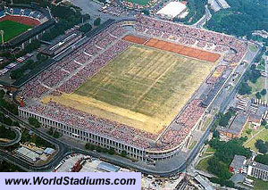

Dome statistics
Weight: | 130,000 tons
DIMENSIONS: Site - 23.9 acres (includes building and one parking lot). Building - 9.34 acres. Roof - 7.85 acres. Height - 250 feet. Width - 660 feet (inside wall); 720 feet (encompassing outside ramps). Volume - 67 million cubic feet within outside columns. Total exhibit space - 190,400 square feet (Arena & 100 level concourse). Parking - approximately 1,100 spaces on-site.
COMPONENTS: Structural Steel - 443 tons. Concrete - 52,800 cubic yards. AstroTurf - baseball, 120,000 square feet, football 80,000 square feet. Lighting - metal halide fixtures, 1500 watts each; 200-foot candles on floor. Sound - 13 high-output arena speakers. Video - Closed circuit television facilities; DiamondVision replay screen with 500 TV monitors throughout the building. Energy Plant - Natural gas heating system, capacity 49.5 million BTU's. Air Conditioning, 4,122 tons of cooling capacity. Restrooms - 18 women, 16 men, 7 first aid wheelchair/unisex. Water Fountains - 87. Executive Viewing Suites - 46 with buffet/bar, private restrooms, elevator/entrance and complete catering services. Seating capacities - Baseball - 60,000. Basketball - 40,000. Football - 66,000.

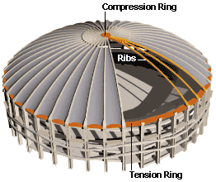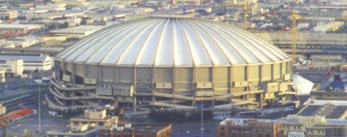

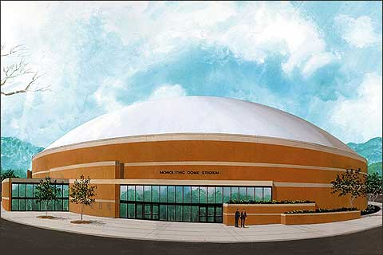The Monolithic Dome can be built up to 1,000' diamteter, making the sky the limit on arena use, size and seating capacity.

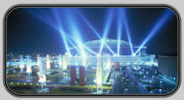
The Georgia Dome, the largest cable-supported domed stadium in the world, is unique in many ways. Here are a few facts about the Georgia Dome that may surprise you.
Structure:
- A total of 8,300 tons of reinforced steel was used to construct the Dome. That is more than the weight of iron and steel used in the Eiffel Tower.
- A 437-mile sidewalk, from Atlanta to Cincinnati, could be built from the 110,000 cubic yards of concrete used at the Dome.
- The building covers 8.9 acres and contains 1.6 million square feet on all seven levels.
- The 290-foot high roof is composed of 130 Teflon-coated fiberglass panels - covering 8.6 acres. The roof's supporting cable totals 11.1 miles and the Dome is as tall as a 27-story building.
Capacity:
- There are 203 executive suites, 4,600 club seats, and the Penthouse Suite. The Dome's permanent seating capacity is 71,250.
- The Dome has three times the code-required number of restrooms - all are accessible to guests with disabilities.
- A pair of C-5 military transport planes could fit on the Georgia Dome’s floor, which contains 102,000 square feet of space.
Utilities:
- 798 lighting fixtures in the roof structure provide lighting.
- The four, 1,250-ton air conditioning units in the Georgia Dome generate enough power to cool 1,666 homes.
- Over 600 television monitors are scattered throughout the stadium.
- To supply soft drinks to dispensers, thousands of liquid lines wind through the stadium. These include 32,952 feet of lines (the length of 109 football fields) to feed liquids to hundreds of dispensers throughout the building, quenching the thirst of sports fans and concertgoers.

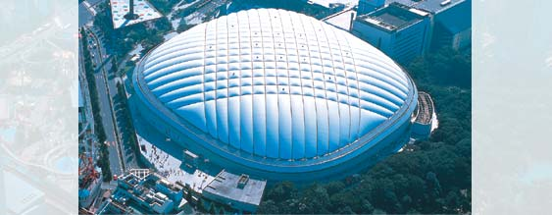
Name: Tokyo Dome "Big Egg"
Location: 3, Koraku 1-chome, Bunkyo-ku, Tokyo
Owner: Tokyo Dome Corporation
Opening Day: March 13, 1988
Area
Site: 112,456 sq m (1.21 x 106 sq ft)
Building: 46,755 sq m (503,267 sq ft)
Field: 13,000 sq m (139,931 sq ft)
Right, Left: 100 m (328.1 ft)
Center: 122 m(400.3 ft)
Capacity: 1,240,000 cubic m (4.378x107 cubic ft)
2 basements, 6 elevated
56.190 m above ground level
61.690 m
55,000
The Tokyo Dome is an air-supported dome. Air is constantly blown into the dome by a pressure fan, keeping the air pressure inside the dome some 0.3% higher than that outside, thus holding up its covering membrane. This pressure difference is equivalent to that between the 1st and 9th floor of a building and is hardly detectable by the human body. FurtherMore, in order to minimize the loss of air from inside the dome, revolving doors are used for all exits and entrances.

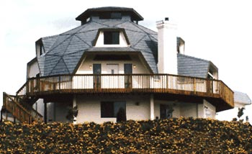




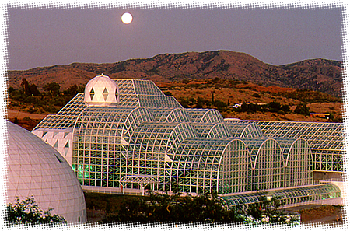


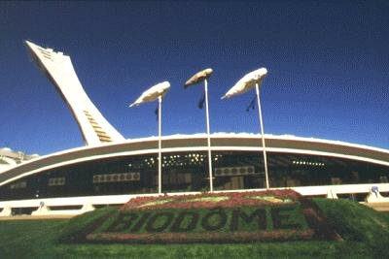


THE ARTEMIS PROJECT  PRIVATE ENTERPRISE ON THE MOON | Shelter for Living on the Moon  Section 2.12.3.

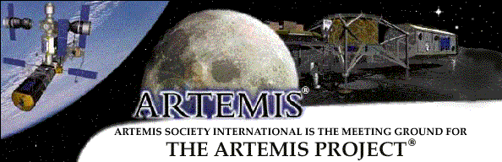

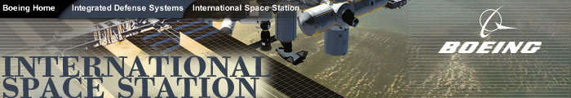

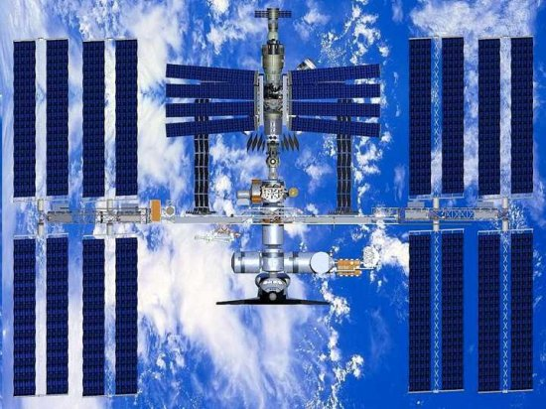International Space Station



